**Seat Heating Application:**

The buttons have to be switched on before the app starts working. Potentiometer acts as temperature sensor. It gives signal which is converted by ADC and used to make a PWM signal pf corresponding duty cycle, as seen in the oscilloscope. As potentiometer is varied, message containing detected temperature is shown in serial monitor.

**SWOT ANALYSIS:**

STRENGTHS:

1. User-friendly

2. Easy to change temperature

3. Low cost

4. Can be installed easily

WEAKNESS:

Applicable to cold countries.

OPPORTUNITIES:

Can be used for other applications by changing the sensors.

Threats:

Not suitable for high temperature regions.

**4W's and 1H:**

what:

seat Heating Application

when:

At Low temperature

Where:

At Automative Industries

**High Level Requirements:**

In the high level requirement, we must have the knowledge of Microcontroller ATmega328.

ATMega328 microcontroller:

The ATmega 328 microcontroller is the current top of the line in the 28-pin ATmega x8 series. It has 32kB flash memory,2kB RAM,and 1kB EEPROM. It can be considered a step up from the ATmega8. It will run at 3.3V with a 16MHz crystal, although it is not recommended due to the possibility of corrupting the EEPROM contents. It has 32 general purpose working registers, three flexible timer/counters with compare modes, internal and external interrupts, serial programmable USART, a byte-oriented 2-wire serial interface, SPI serial port, 6-channel 10-bit A/D converter, programmable watchdog timer with internal oscillator, and five software selectable power saving modes. The device operates between 1.8-5.5 volts. Its maximum operating frequency is 20MHz. This is the CPU (Central Processing Unit) of our project. We use microcontroller ATMega328for reading the temperature and holding the monitoring and the controlling program. It receives the analog voltage signal coming from the sensor. After the conversion into digital signal, it checks whether the sensed value is in the set value. If the data does not come under the set parameter, then the microcontroller starts its controlling action.

[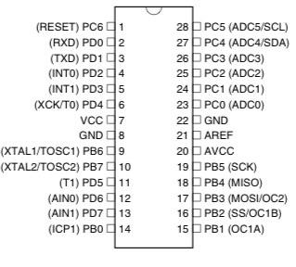](https://user-images.githubusercontent.com/94346768/144083604-d9c00ff7-81db-49ee-93d0-eca6ed65a257.png)

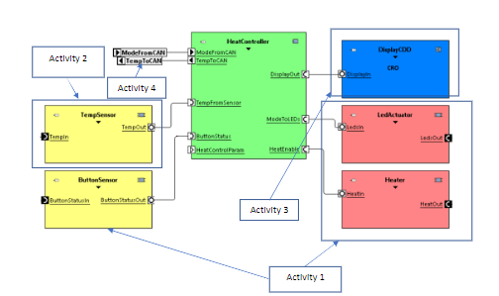

The buttons have to be switched on before the app starts working. Potentiometer acts as temperature sensor. It gives signal which is converted by ADC and used to make a PWM signal pf corresponding duty cycle, as seen in the oscilloscope. As potentiometer is varied, message containing detected temperature is shown in serial monitor.